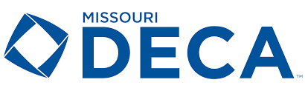

The Officer Application will be available January 24 2022. It is being revised by the DECA Board.

